Design Thinking SCAMPER Assignment

 Gathering Advertisements

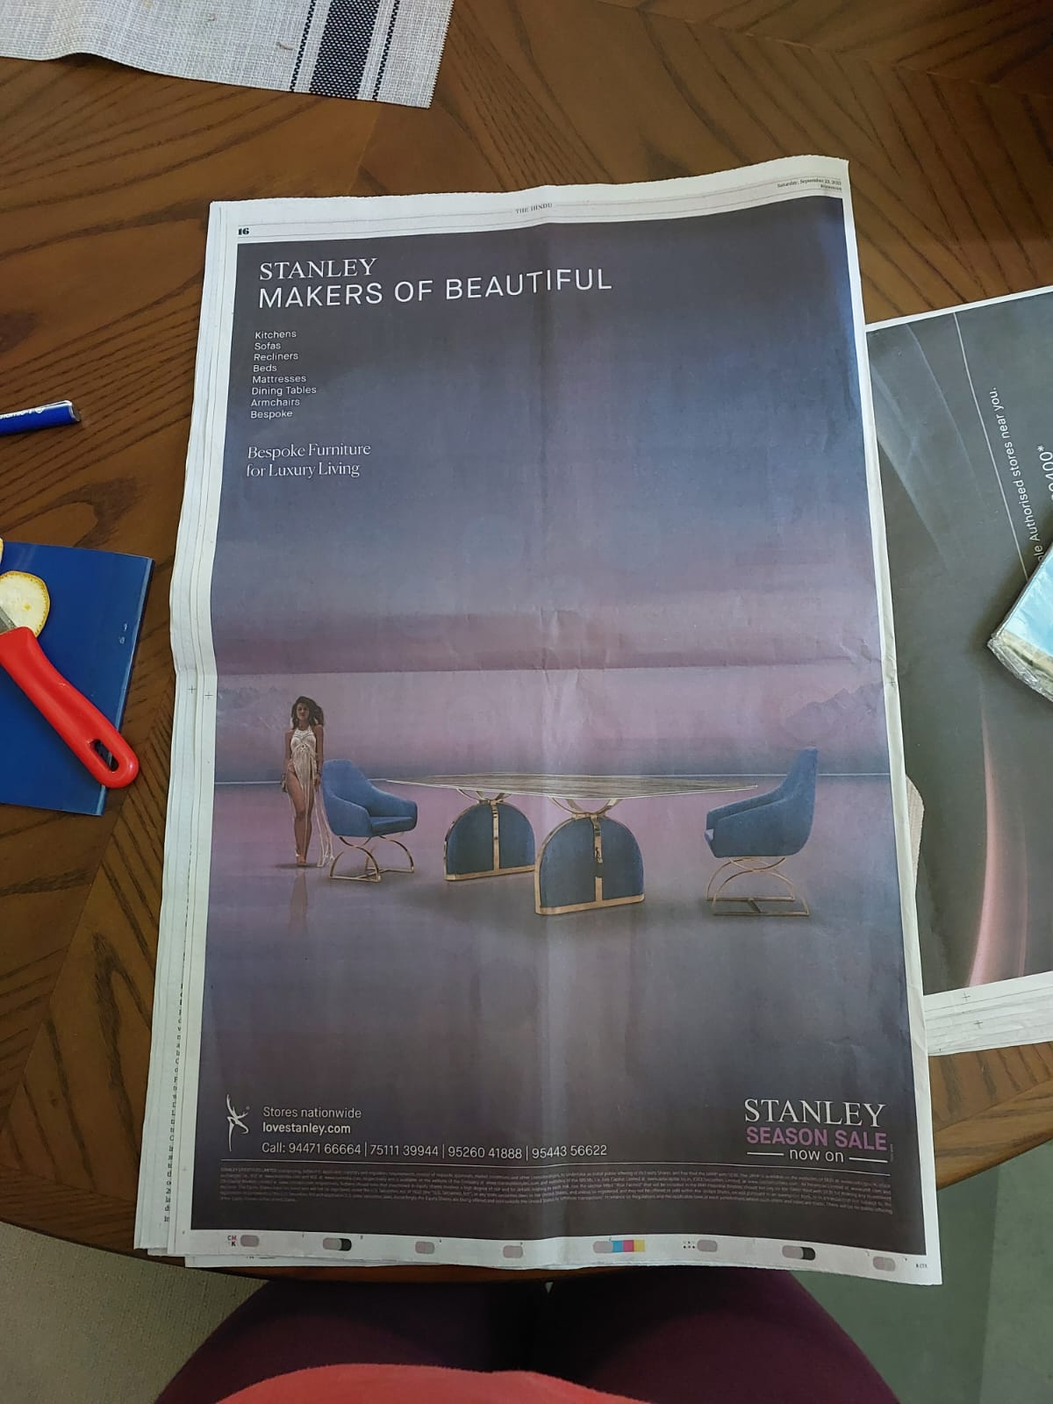

We will be working with these 2 advertisements. Let us analyse both of them.

1. MacBook Air

Their selling points:

1. Affordable EMI when exchanged for another laptop
2. Large Screen
3. Newer and more powerful processor(M2 chip)
4. Longer battery life
5. High Performance
6. Portable (Easy for travel unlike Gaming Laptops)
7. The picture gives a minimalist feel to the design. This is because it is targeted to people who use their laptops as a workstation and wouldn’t want any distractions.
8. Also, the wallpaper is attractive

Let us discuss how they used SCAMPER to design this product

1. Adapt (to users’ needs)
2. Their previous model (2020 model) used to have a 13.3-inch retina display. The older model used to have a 2560×1600 display (This was better than Full-HD but worse than 4K). The larger screen in the newer model allows for them to have a 4K display which is the standard nowadays.
3. They say that the battery life is 18 hours. But I doubt it. My friend Faheem as a MacBook Pro and he says that he only has to charge the laptop once in every 3 days. Apple might be being too humble here or they are stating the battery life when it is used under continuous heavy load. Either way, it must be an improvement over the previous generation since it also charges faster.
4. Improve

The M2 processor is a huge improvement from the M1 chip. M1 only had 16 billion transistors while M2 has 20 billion transistors. The processing speed is 3.5 GHz as opposed to 3.2 GHz. It has 8core CPU and 10 core GPU as opposed to the older 8 (meaning we can do more tasks at the same time). Writing speed is 100GB/s as opposed to 68.25 GB/s

1. Put to another use

They could have advertised about IoT (Internet of Things) as it is becoming more and more common nowadays. Mac systems are extremely good for such uses as they are extremely compatible with iPhones, iPods, Apple TVs and Apple Watches. They could have made a point about how you could store files in your home computer and easily access them from your phone when you are travelling. Or the ability to answer calls and messages from your laptop instead of relying on your phone.

Now. Next product…

1. Stanley

Initial Analysis:

1. I don’t know this company. So, there isn’t much brand value to me.
2. Nothing in the ad stands out. There is text at the bottom saying SEASON SALE, but it doesn’t make me excited.
3. I don’t get much information other than the fact that it is a furniture company. The dining table set looks okay but doesn’t really tell us why it is different from other companies.
4. It takes the full page but looks very blank.

Conclusion:

I don’t think they successfully applied scamper to this product or advertisement.

Hence, Let’s improve it.

Step1:

Let us take a picture of their product from google.

It is a dining table.

Step2:

Most of the target demographic is going to be families. So…

Step3:

Make the Logo and “Summer Sale” bigger to catch the eye. And add “40% off” to make them less unsure of whether to buy or not

Step3:

Add the names of other products they sell and also showroom locations to make it more informative



Scamper analysis:

1. Substitute

The earlier version had a half naked lady. This type of advertising generally targets men. We substituted that with a family to target a larger demographic.

1. Modify

We made the “summer sale” font bigger to make it the central theme of our ad.

1. Eliminate

We eliminated a lot of blank spaces. This makes the ad a half page ad but also much more effective